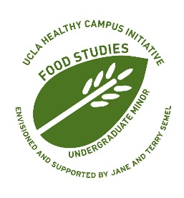 | UCLA Food Studies Minor  The Marcie Rothman Centennial Scholars Undergraduate Scholarship
Application Form
The Marcie Rothman Centennial Scholars Undergraduate Scholarship was established to support students in the Food Studies minor with their academic and research endeavors at UCLA. The recipient(s) must be enrolled in the undergraduate Food Studies minor and demonstrate financial need and/or merit. This scholarship is awarded annually to one or more Food Studies minors. It aims to foster the enrichment and reach of Food Studies as an area of interdisciplinary study, including research and practice related to cultural dimensions of food systems and culinary traditions, public health, nutrition, sustainability, ecology, food activism, and social and environmental justice.

To be eligible for the scholarship, a student must:

- Be in good academic standing, and;
- Be admitted to the UCLA Food Studies minor.

To apply to the scholarship, please complete this form and submit it with your (1) scholarship statement, (2) résumé, and (3) a copy of your unofficial transcript. Please review the website for more instructions.

All required application materials must be submitted by Monday, October 30, 2023, at 11:59PM to the Marcie Rothman Scholarship Committee. Late and/or incomplete applications will not be considered.

Applicant Information
Full Name:
 | Last |  | First |  |  |  |  |  |  |  |  |  |  |  |  |  |  | M.I.
9-digit UID:
Email Address:
Major(s):
Minor(s):
Are you eligible to receive Financial Aid? | ☐ Yes ☐ No |  | List any minor courses that you have completed or have in progress: (e(e.g. ENVIRON 25, FOOD ST 133W, ANTHRO 133, etc.)

